**A PROJECT REPORT**

Presented to Intelint Technologies

Bangalore, Karnataka.

**SCHOOL WEBSITE (SONA VALLIAPPA PUBLIC SCHOOL)**

**TEAM MEMBERS:**

* **M. Jana (Team Lead)**
* **M. Arun Kumar (Team member)**
* **S. Ishwarya (Team member)**
* **M. Balaji (Team member)**
* **Swadha Siva kumar (Team member)**

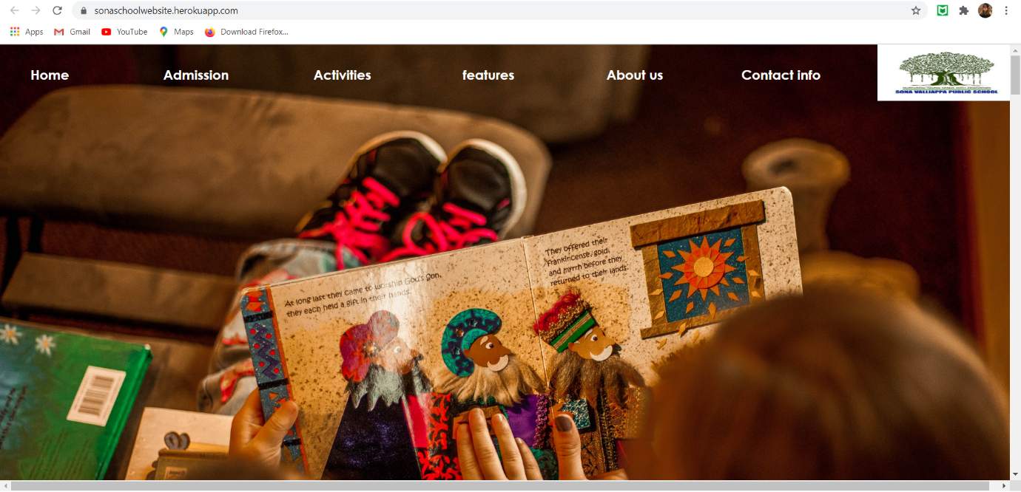

**Project Description:**

* **We create a static school website, now in our college they are introducing kindergarten preschool. For that idea we created a wonderful website for sona valliappa public school site.**
* **We create this website with full focussed and creative Ideas.we worked as a team in unity and done this project successfully.**
* **By this way we continue the features and functionalities of the project.**

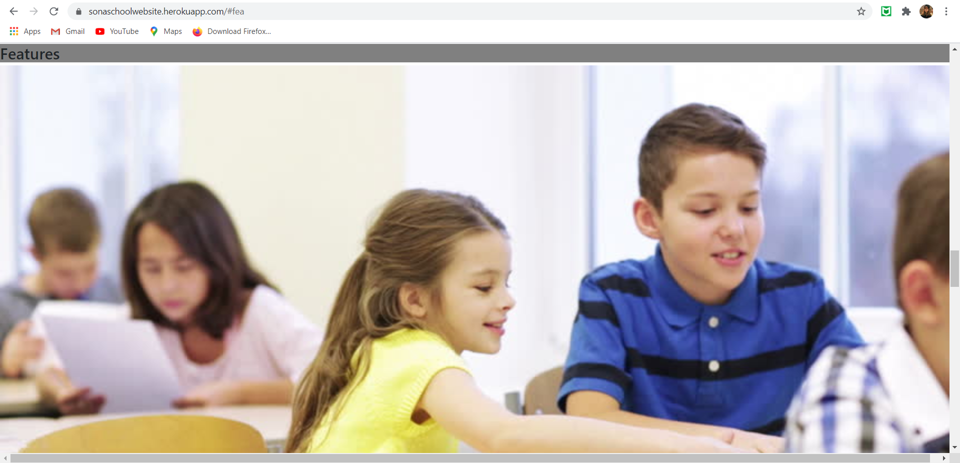

**Features / Functionalities:**

* **In this website we attached all the information about the school like user can see all the information of admission, fees details, contact info Google API map location etc.**
* **We created better than given in the project question requirement.**

* **We gave our best to Design a attractive website project.**
* **It’s very user-friendly website that everyone can access like getting information about all details of school facilities etc.**

* **And also we created a attractive UI to make user good experience.**
* **By this way we continue to the Tools and Technology we used to create a website.**

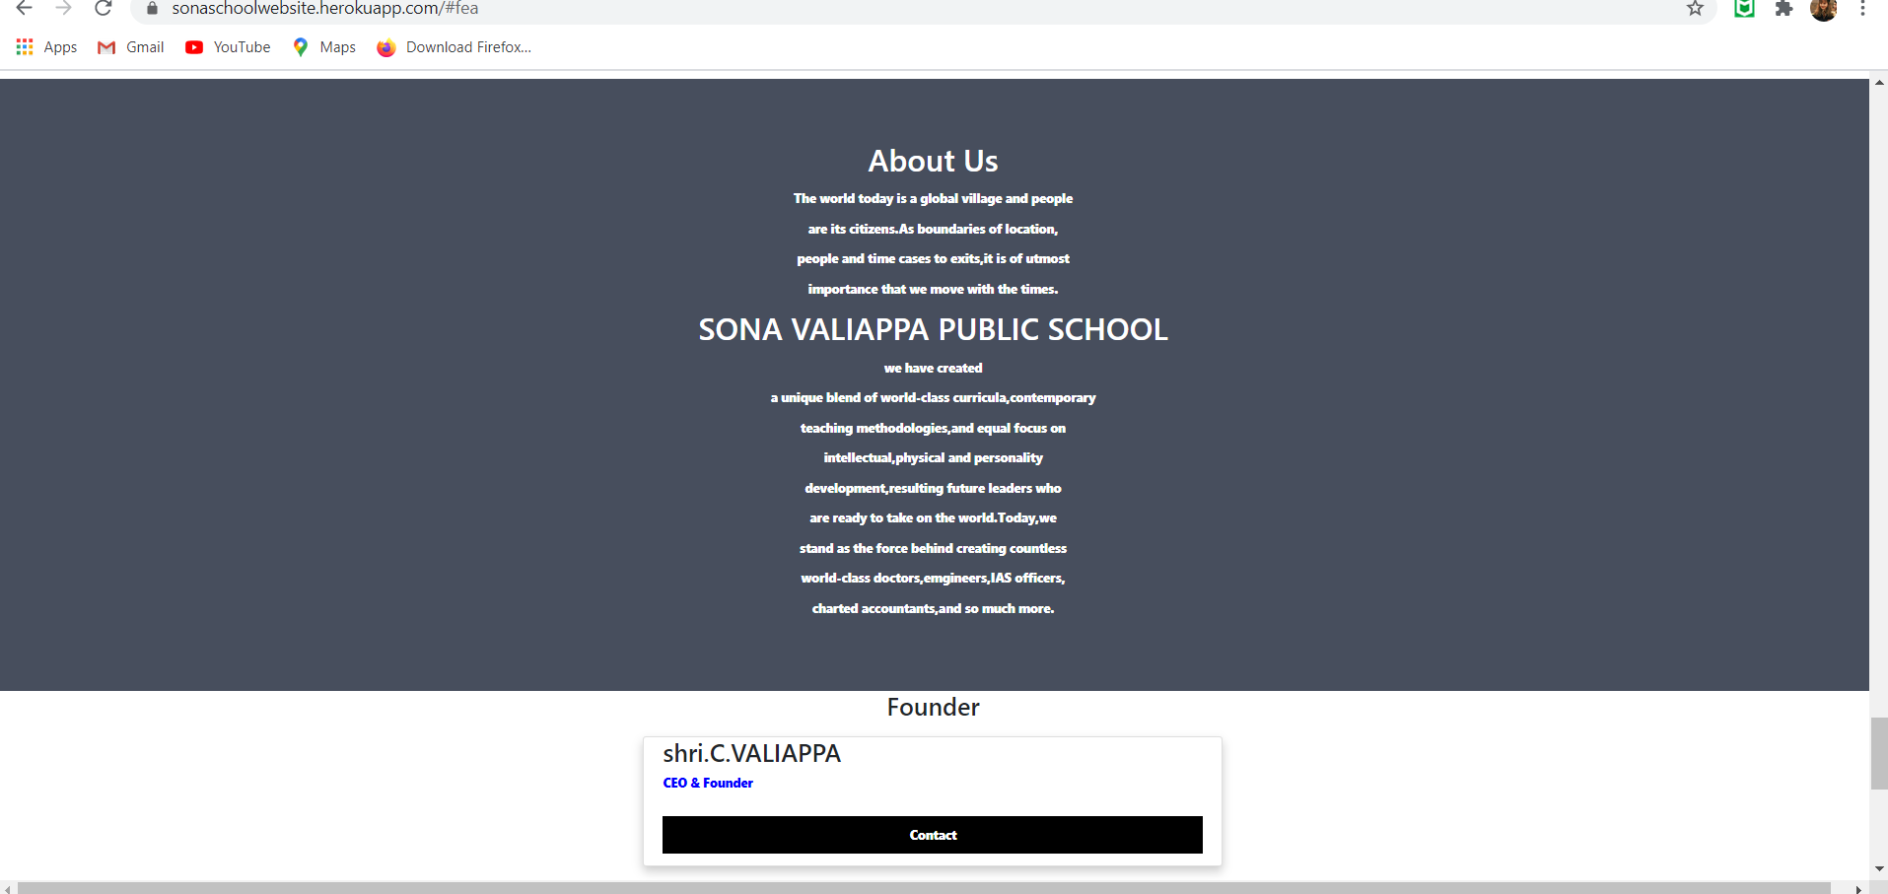

**Tools and Technologies:**

* **Tools that we used to create this website is:**
* **Visual studio code.**
* **Sublime Text editor.**
* **Jira.**
* **Heroku.**
* **UI Design.**
* **Technologies that we used:**

**We used HTML (Hyper Text Markup Language) to structure the website and we used CSS (Cascading Style Sheets) to make our website attractive designs and we add location using Google API (Application Programming Interface)**

**DEMO -SECTION:**

**URL of the project:** [**https://sonavalliappaschool.herokuapp.com/index.html**](https://sonavalliappaschool.herokuapp.com/index.html)

|  |
| --- |
| **THANKING YOU.** |